Intent
- Facade defines a higher-level interface that makes the subsystem easier to use.
- Wrap a complicated subsystem with a simpler interface.

Problem
A segment of the client community needs a simplified interface to the overall functionality of a complex subsystem.

- Facade as the name suggests means the face of the building.
- The people walking past the road can only see this glass face of the building.
- They do not know anything about it, the wiring, the pipes and other complexities.
- The face hides all the complexities of the building and displays a friendly face.
It hides the complexities of the system and provides an interface to the client from where the client can access the system.

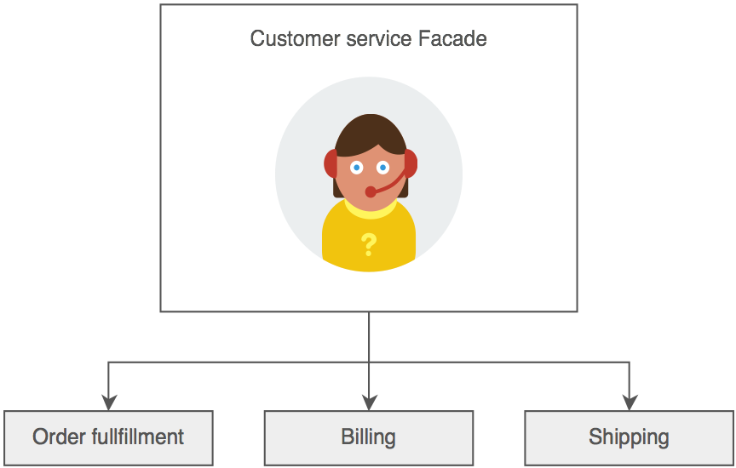
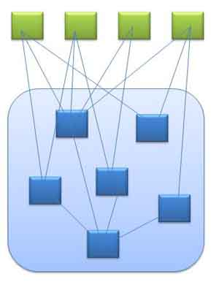
In Java, the interface JDBC can be called a facade. We as users or clients create connection using the “java.sql.Connection” interface, the implementation of which we are not concerned about. The implementation is left to the vendor of driver.
Façade
Action – façade – service – repository or Controller– façade – service – repository
Sales Façade - Sales service
Purchase Façade - Puchase service.
Account Façade - Accounts service

If Accounts service needs purchase service, it cant call directly the purchase service. 1) Accounts façade calls part of account service first,
2) then purchase facade second.
3) Transaction starts from Account façade- Account Service- Purchase Façade- Purchase Service

